Configuration Steps:
You first need to put your PC on a network that can reach the device IP 10.115.32.10. A practical way is to connect the Pi directly to your PC with an Ethernet cable and temporarily give your PC a compatible Ethernet address.
1. Connect the Pi directly to your PC using Ethernet.
This method assumes 10.115.32.10 is assigned to the Pi’s Ethernet interface, rather than its Wi-Fi interface. A USB-to-Ethernet adapter works if your PC lacks an Ethernet port.
2. Temporarily configure your PC’s Ethernet adapter.
On your Windows PC:
- Press Win + R, enter ncpa.cpl, and press Enter.
- Right-click the Ethernet adapter connected to the Pi → Properties.
- Select Internet Protocol Version 4 (TCP/IPv4) → Properties.
- Record its existing settings, then enter:
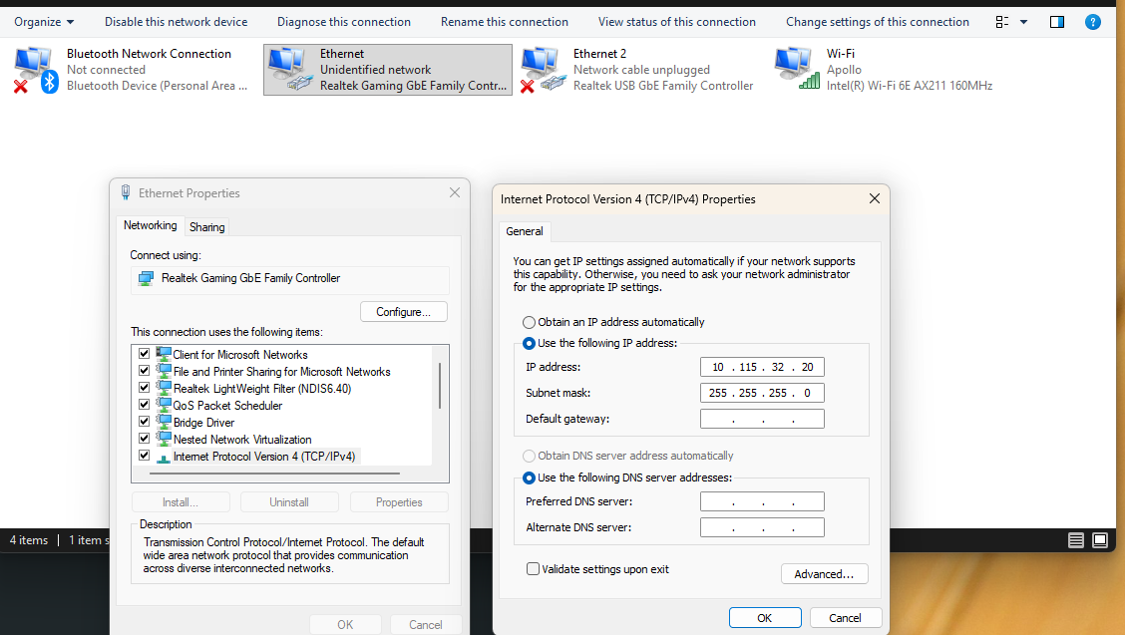
This assumes the Pi uses a /24 subnet mask (255.255.255.0). If its mask differs, match its actual subnet. Leave your PC’s Wi-Fi settings unchanged.

3. Open PowerShell as Administrator on your PC:
Enable remote connection
Net Start WinRM
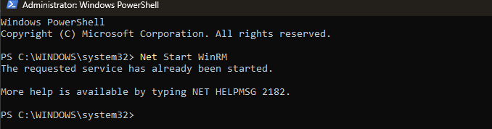
Test the connection
Test-NetConnection 10.115.32.10 -Port 5985
Verify TcpTestSuccessed = True
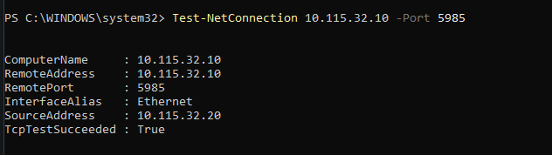

Enter Trusted Host List.
Set-Item WSMan:\localhost\client\TrustedHosts – value 10.115.32.10
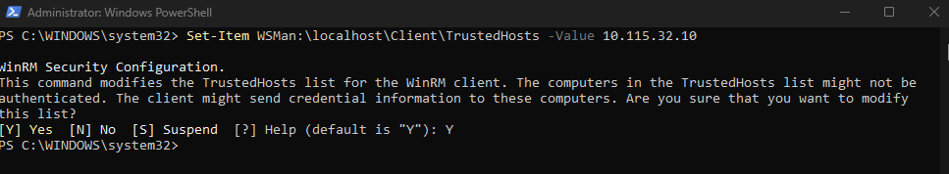
4. Start PowerSell Session
Enter-PSSession -Computer 10.115.32.10 -Credential 10.115.32.10\Administrator
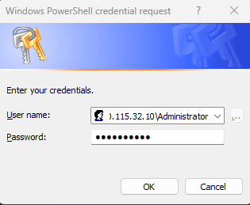
You are now connected and logged in to the device.
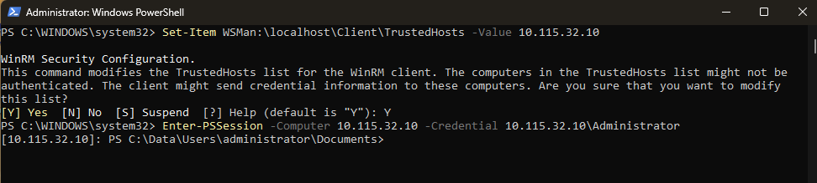

6. Display current network interfaces
netsh interface ipv4 show config
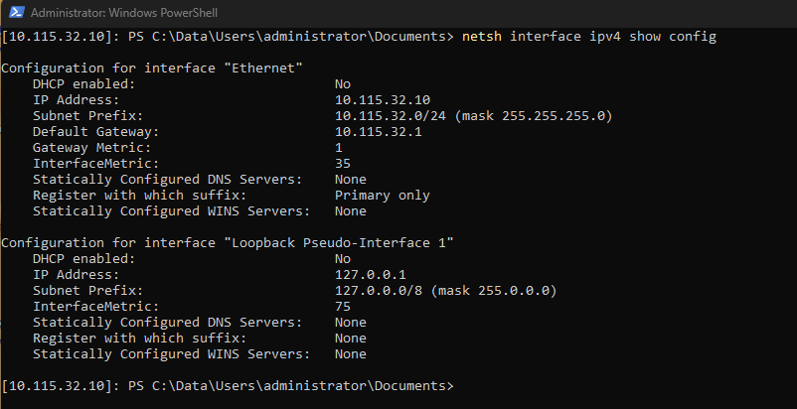

7. Set Static IP
netsh interface ip set address “Ethernet” static 10.115.32.10 255.255.255.0 10.115.32.1
8. Display new network interface settings
netsh interface ipv4 show config
